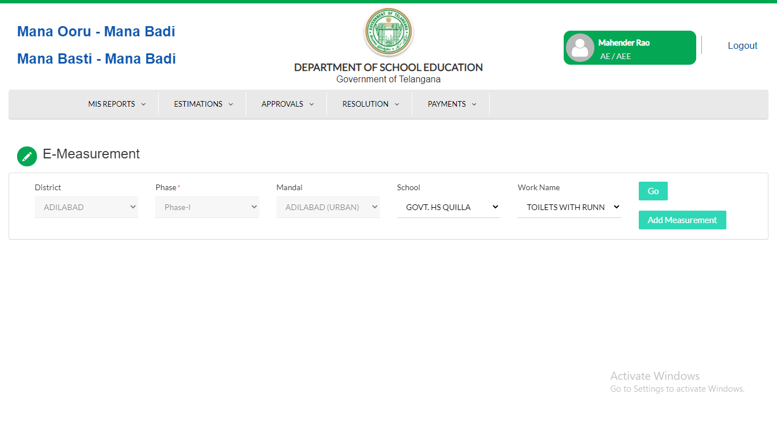

AE Login:

Link Path:Payments-->M Book Progress

Select the School,work name and click on Add measurement then you will see the below screen for adding the measurements.

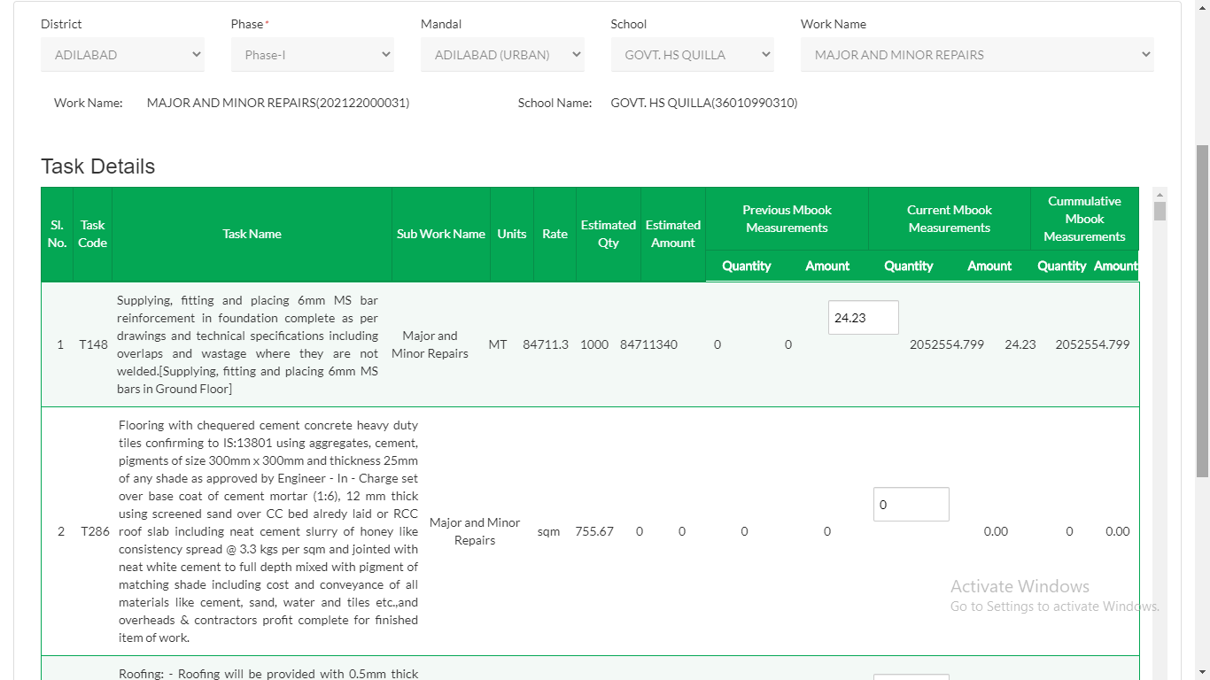

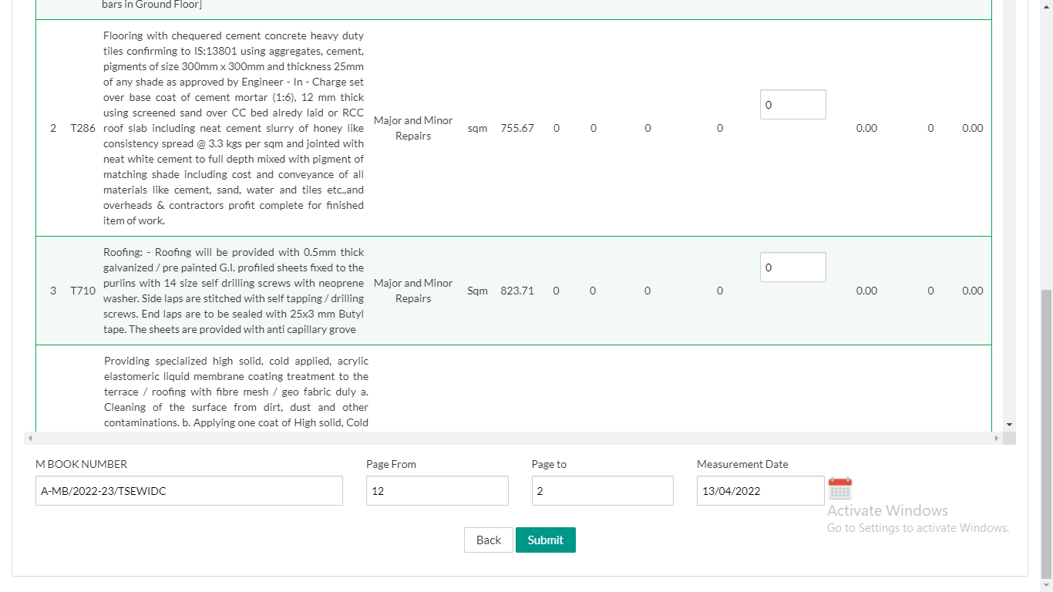Enter Mook Number,Page from, Page to and Measurement date and click on Submit button after entering the quantities.

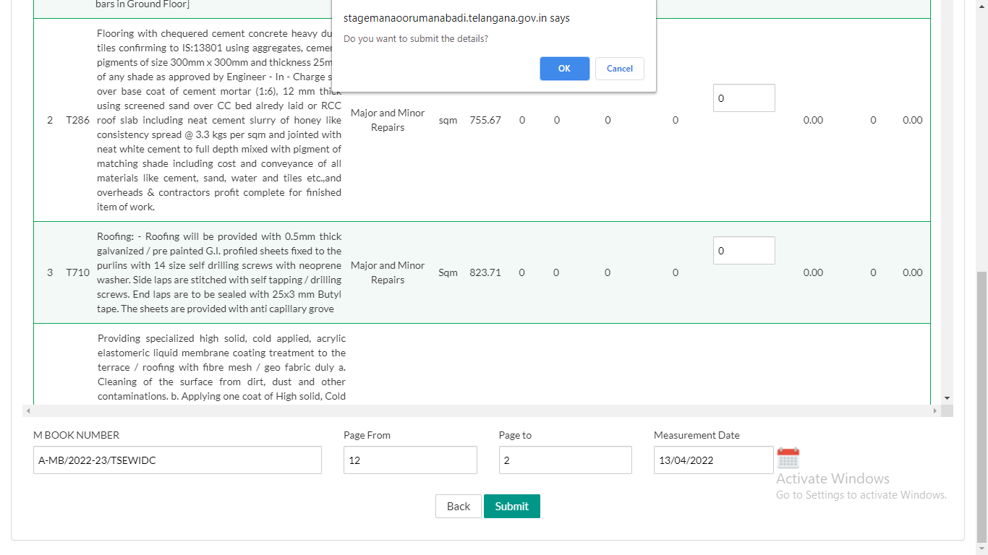

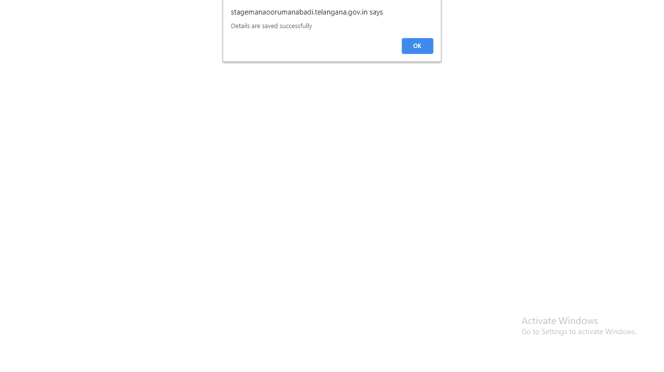

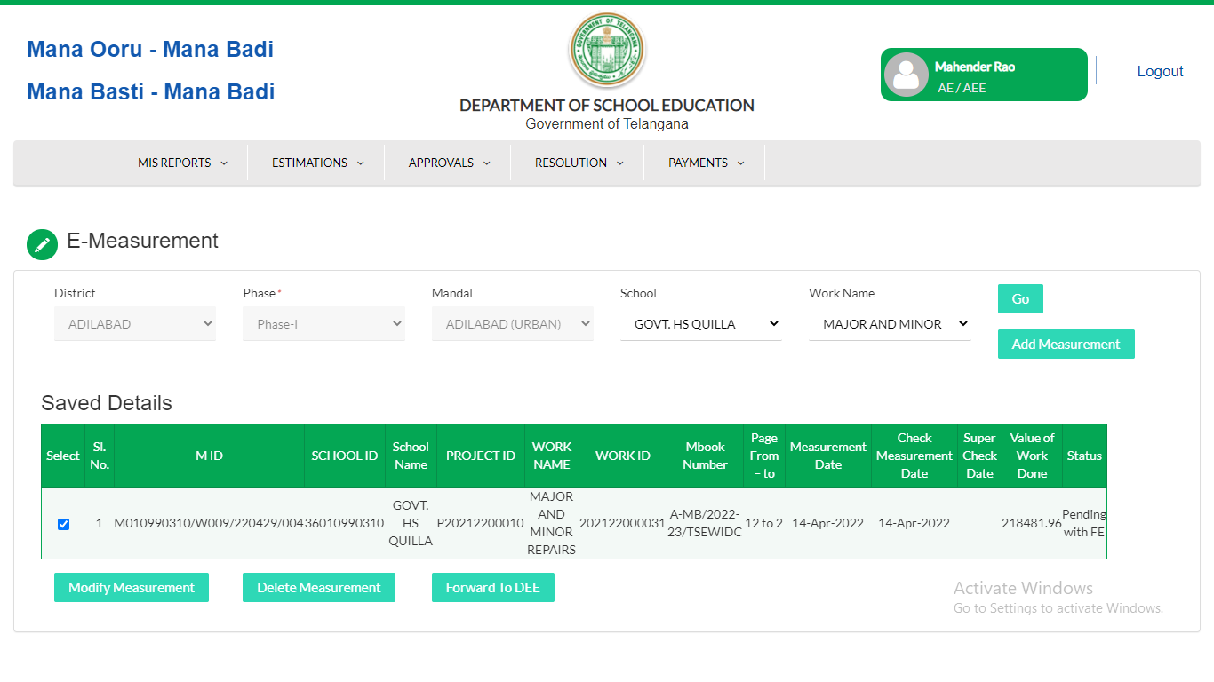

Actions:

Modify Measurement:If the User wants to modify measurement then click on Modify measurements.

Delete Measurement.If the User wants to Delete Measurement then clikc on Delete Measurement.

Forward to DEE:If the User wants to Forward then click on Forward to DEE.

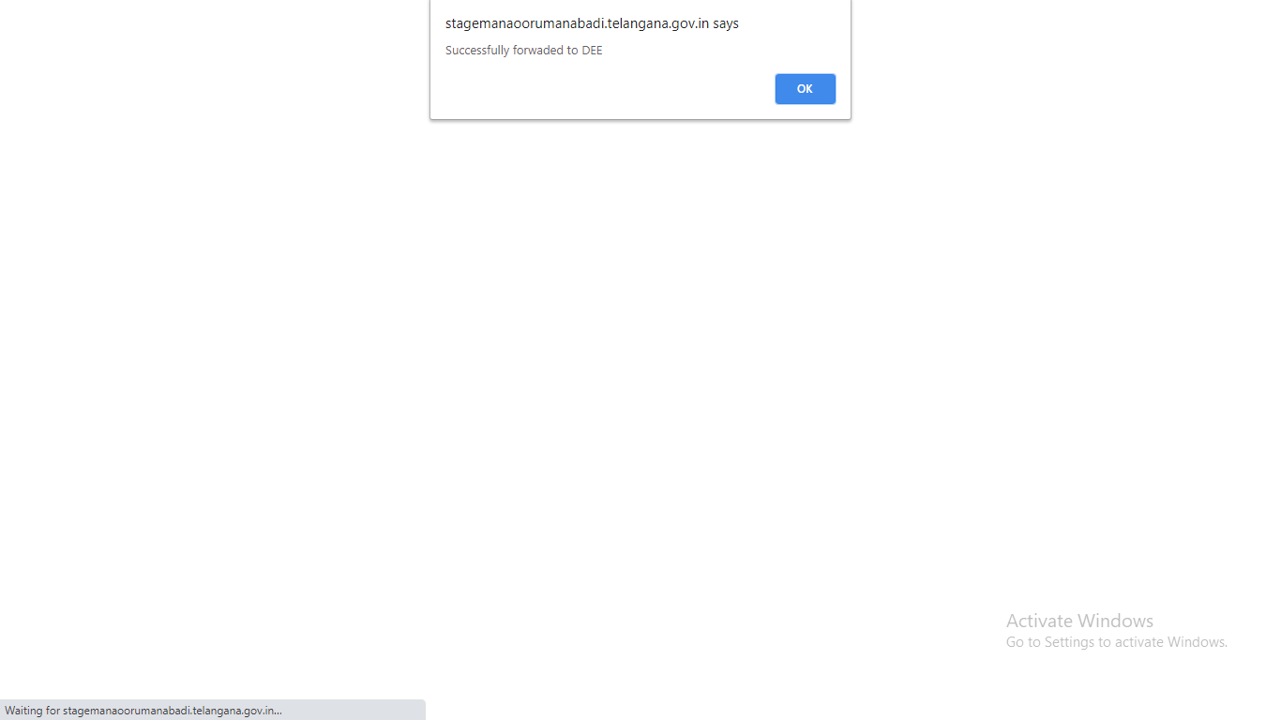

**DEE Login**

Link Path:Payments-->Mbook Progress Approval

Select Mandal-->School-->Work name and select the check box

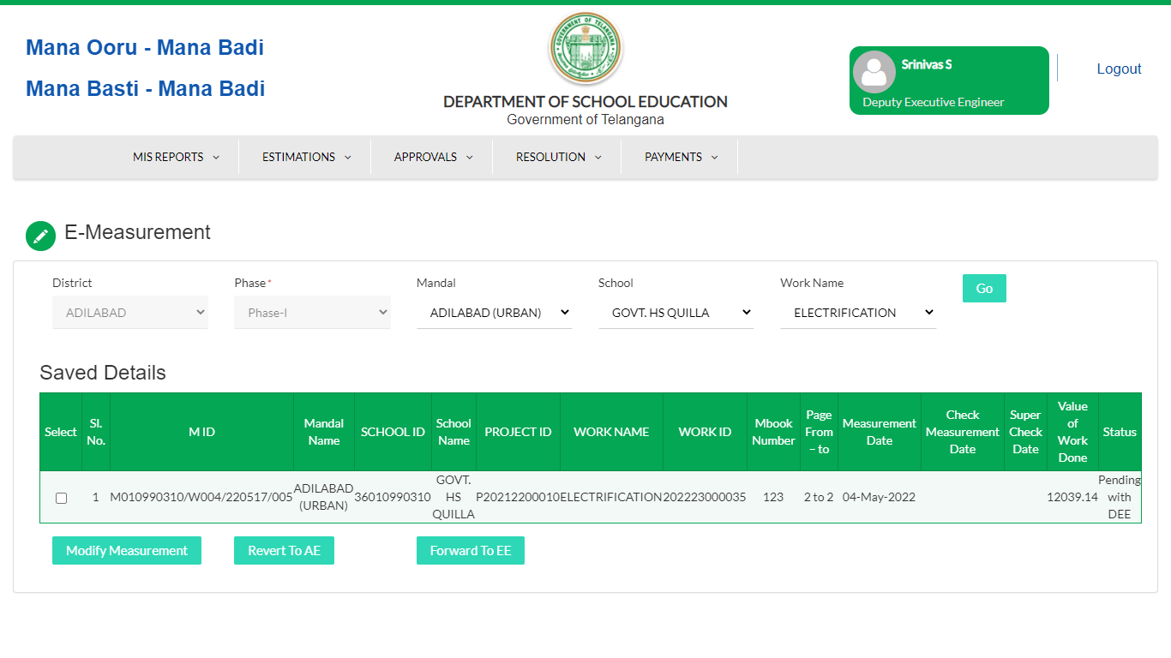

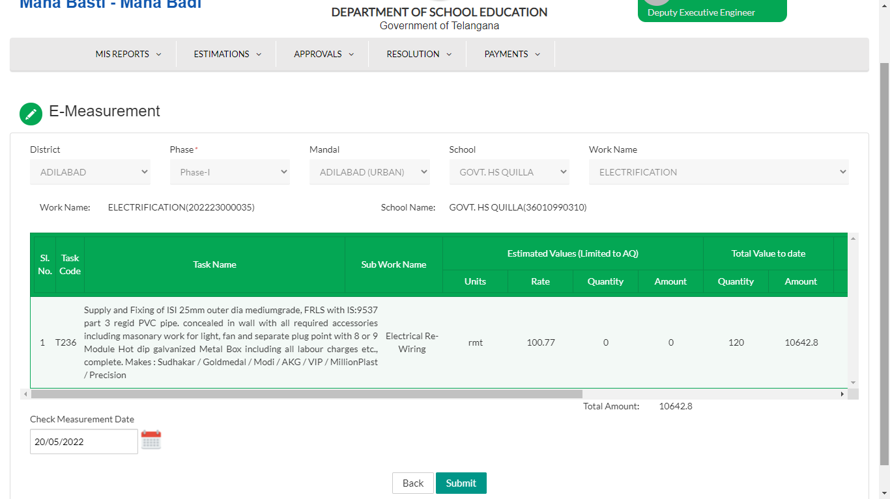

Actions:

Modify Measurement:If the User wants to modify measurement then click on Modify measurements.

Revert to AE .If the User wants to Revert the Measurement to AE then click on Revert to AE button.

Forward to EE:If the User wants to Forward then click on Forward to EE.

While forwarding to EE: user needs to Modify measurment and select Check Measurement Date and submit.

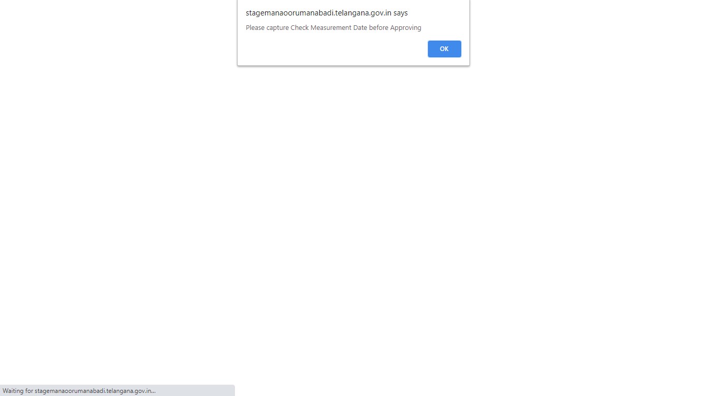

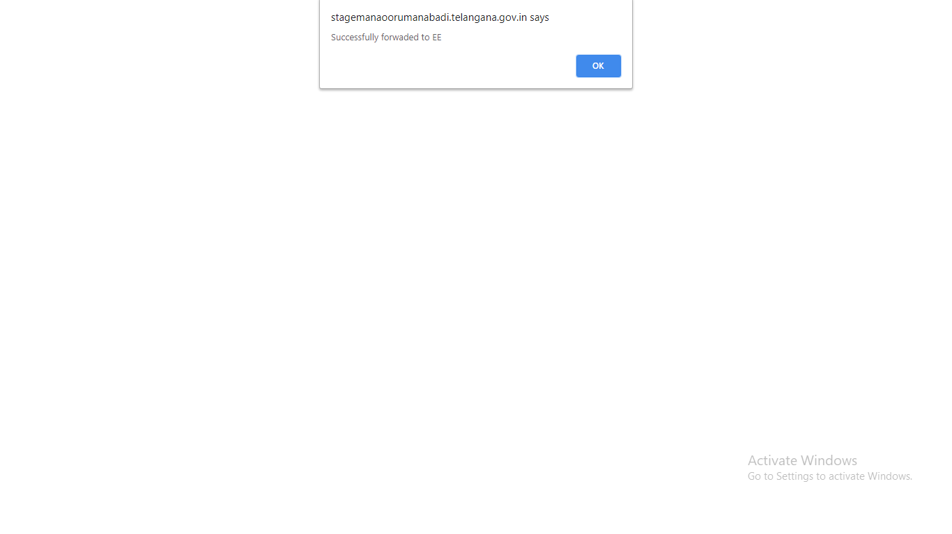

**EE Login**

Link Path:Payments--> Mbook Progress Approval

Select Mandal,School,work Name

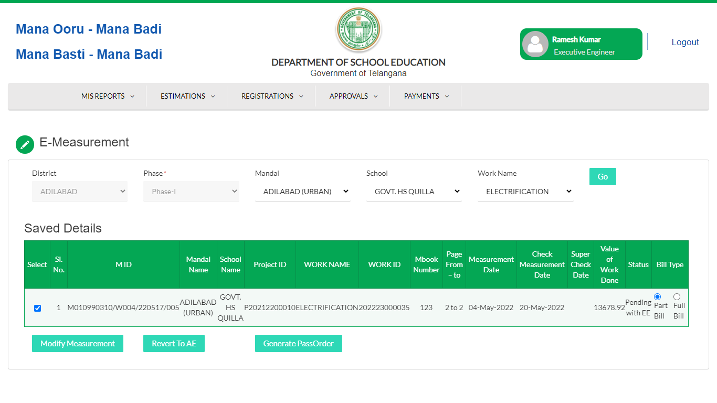

Actions:

Modify Measurement:If the User wants to modify measurement then click on Modify measurements.

Revert to AE .If the User wants to Revert the Measurement to AE then click on Revert to AE button.

Generate Pass Order:If the User wants to Generate Pass order then click on Generate PassOrder Button.

While Generating Passorder: User needs to Modify measurment and select Super Check Date and then Generate Pass Order.

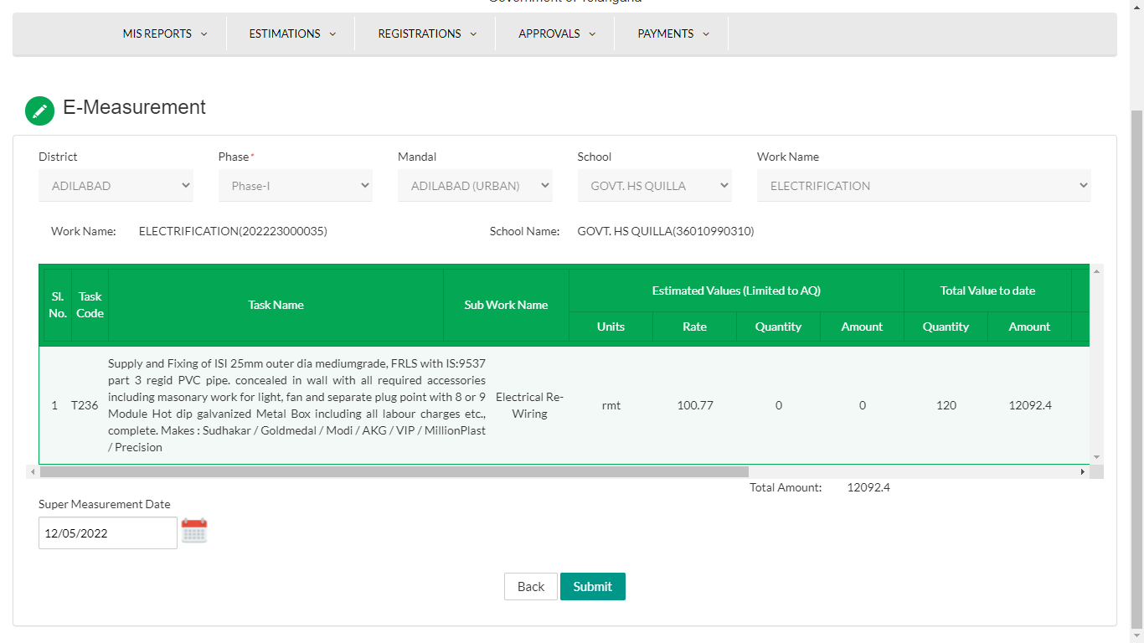

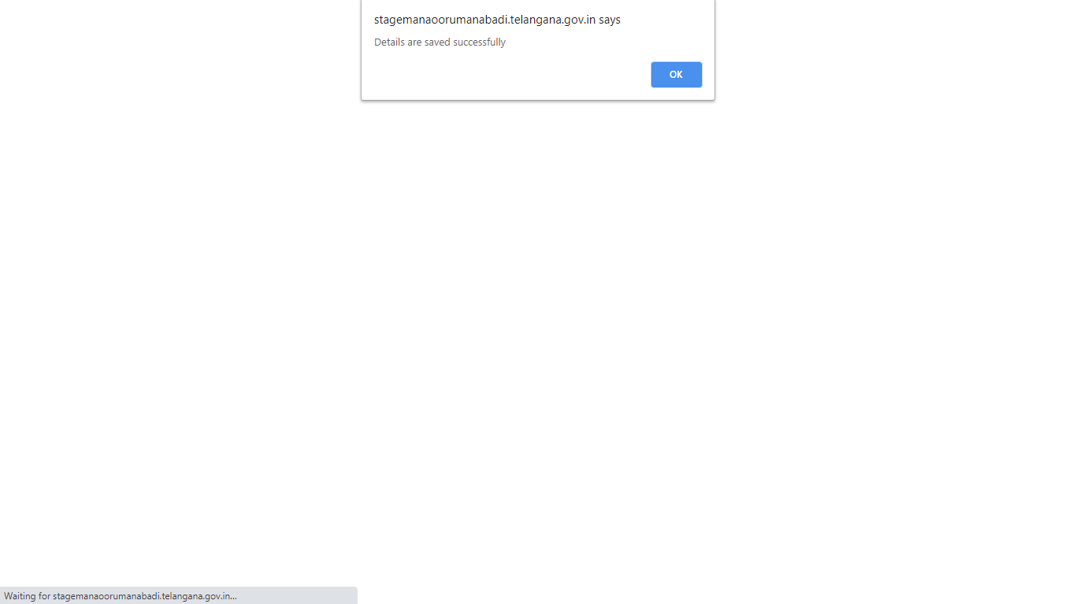

After Succesfully saved Measurements then click on Generate Passorder Pop UP message is showing in the below screen as Passorder generated Successfully.

**Note**:User Select the Bill as “FULL BILL” system is not allowing to Submit new Measurements.

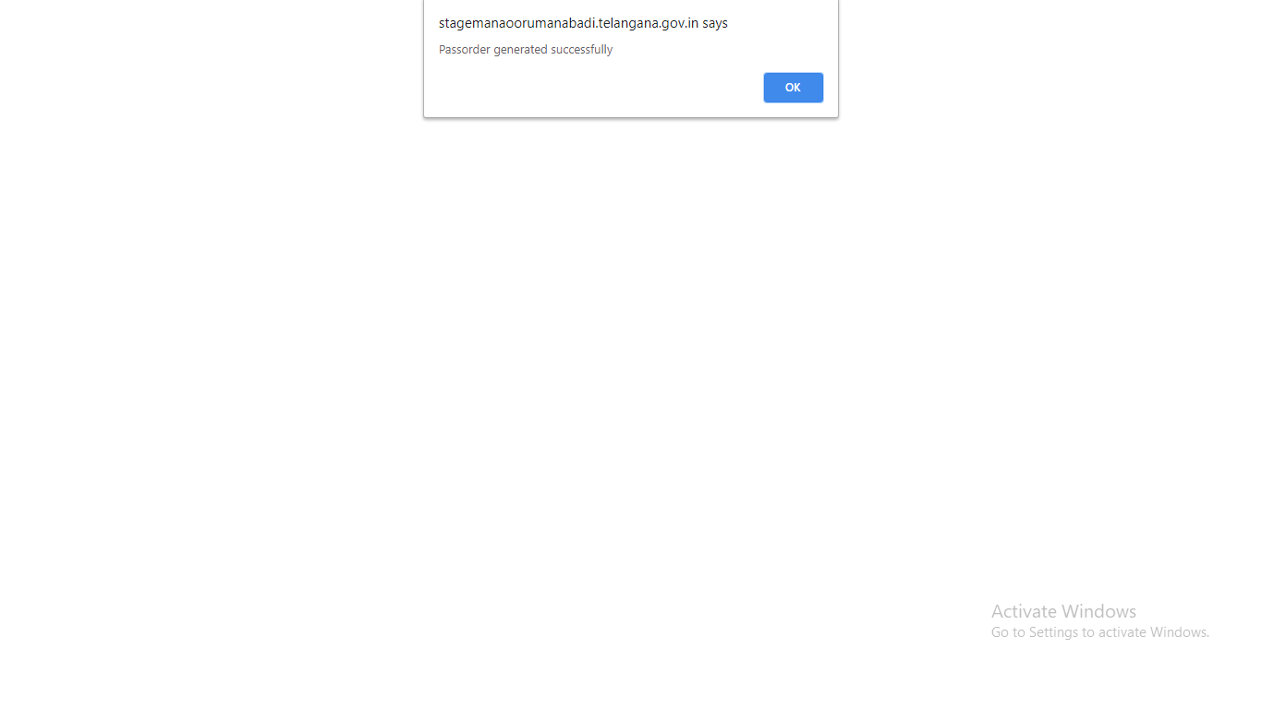

Passorder PDF is showing below screen.

